Ec2 Task
- Launch one EC2 using Amazon Linux 1 image and add a script in user data to install Apache.
- Instance creation process updated all the configurations required and script added for install Apache.
- Script added under User data Amazon Linux 1

- Launched the instance successfully.

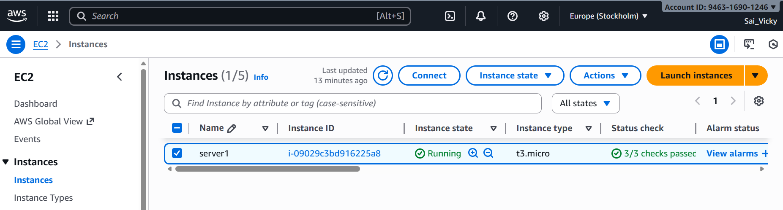

- Now, we have finally created a server-apache named “server”

- Open a terminal in local and add the link with ec2 server.

- Ssh -i “pem.key” ec2-user@”ip”

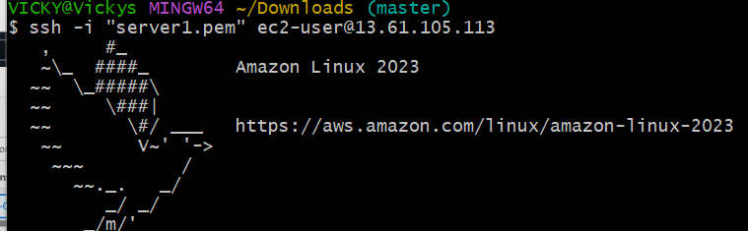

- Now verify if “Apache” is installed from the script added, using command- “systemctl status httpd”
- Success, the script worked and apache is installed and running.
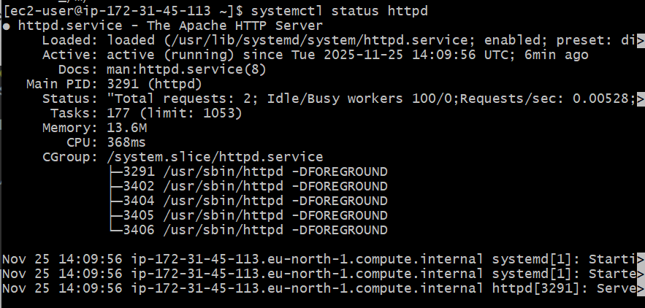

- Verified the port number with ip from ec2.
- Success.
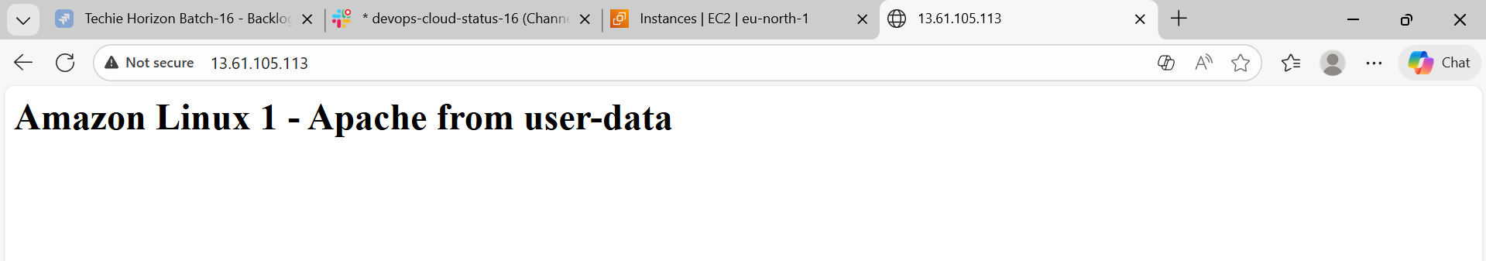

- Launch one EC2 using Ubuntu image and add a script in user data to install Nginx.
- Creating a new ec2 server and named ubuntu-nginx
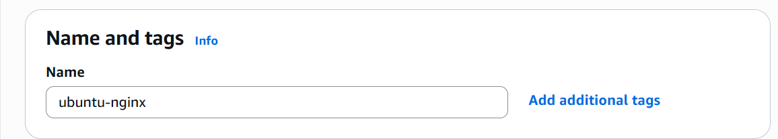

- Selected Ubuntu in the AMI.
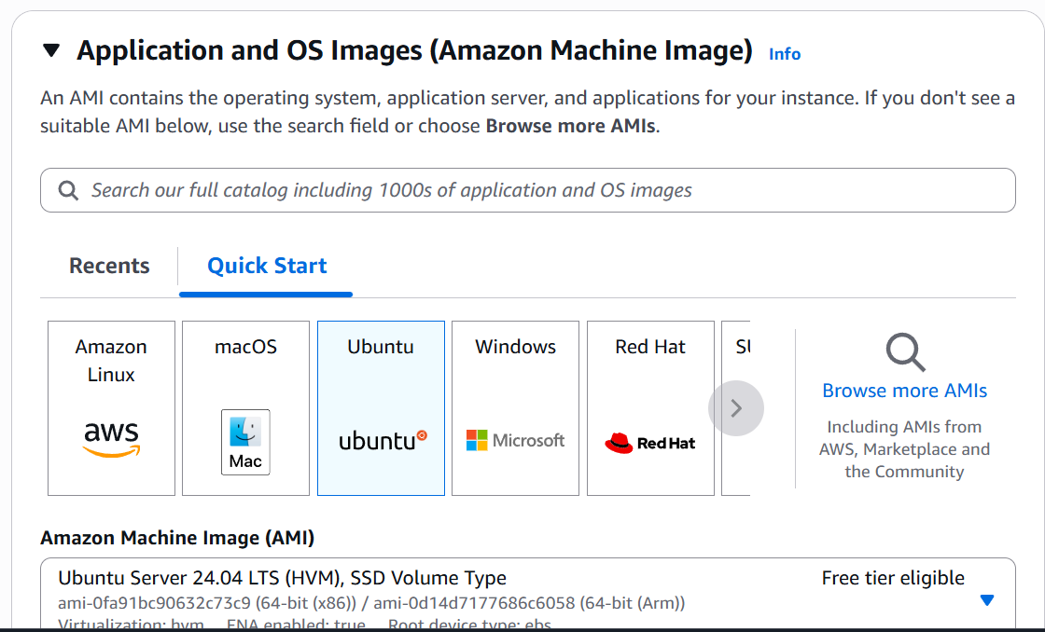

- Script added to install nginx in user data.
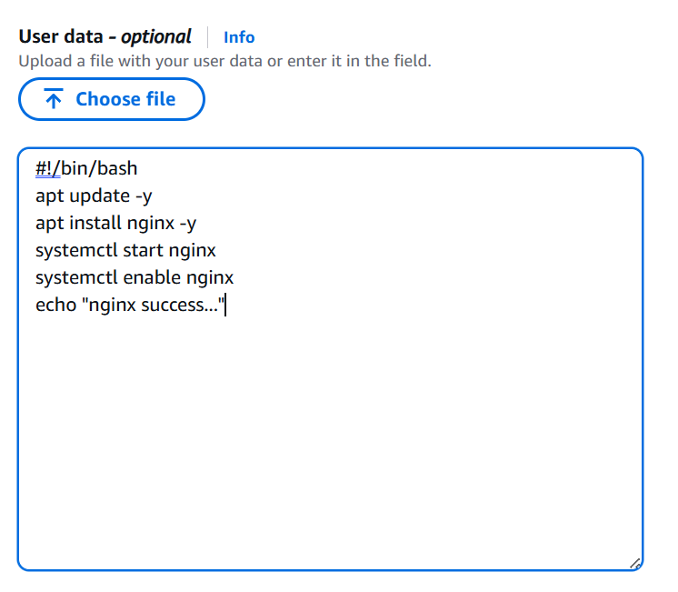

- Instance created.

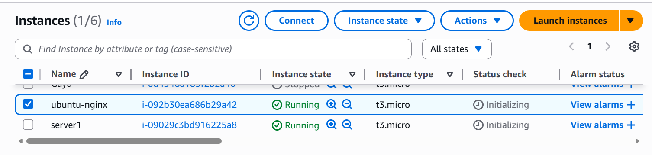

- In the local machine, used the ssh key to launch the ec2 server.
- Success- script worked and Ubuntu image created successfully.
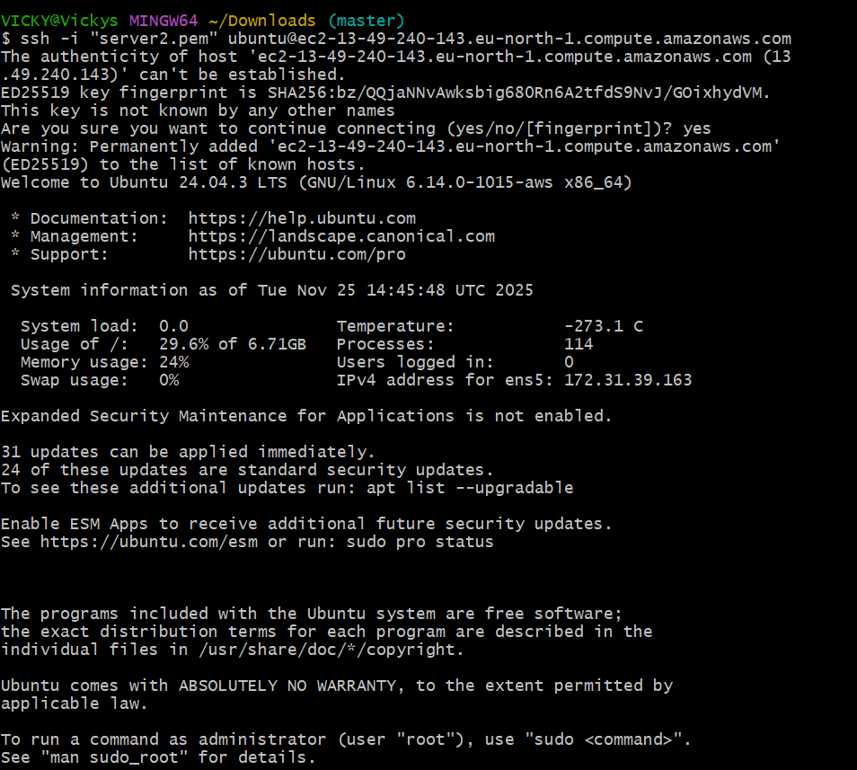

- Verified is the nginx is installed as per the script. Yes- nginx got installed and by using command- sudo systemctl status nginx.

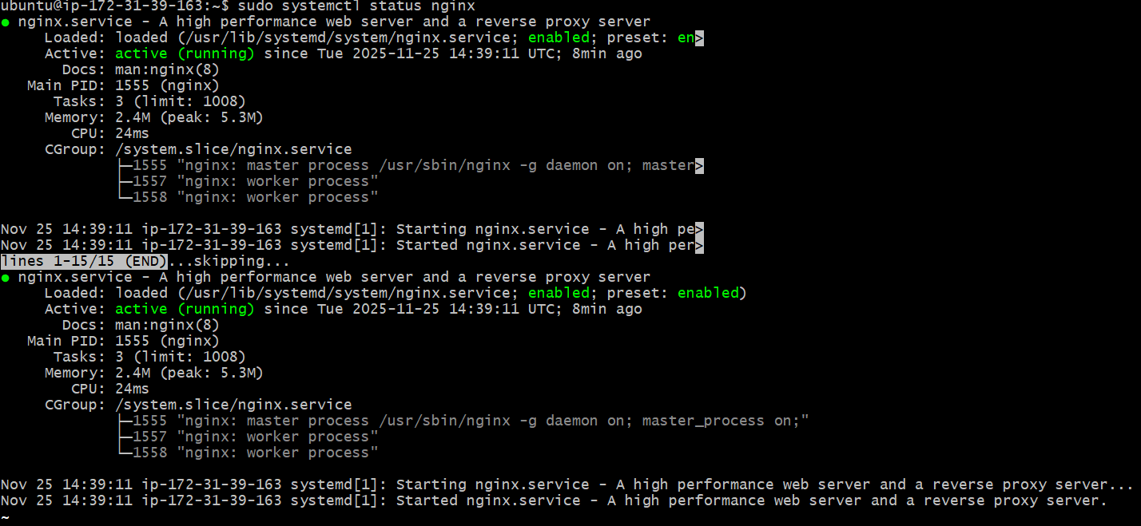

- Success, nginx is working on port 80 with IP address.

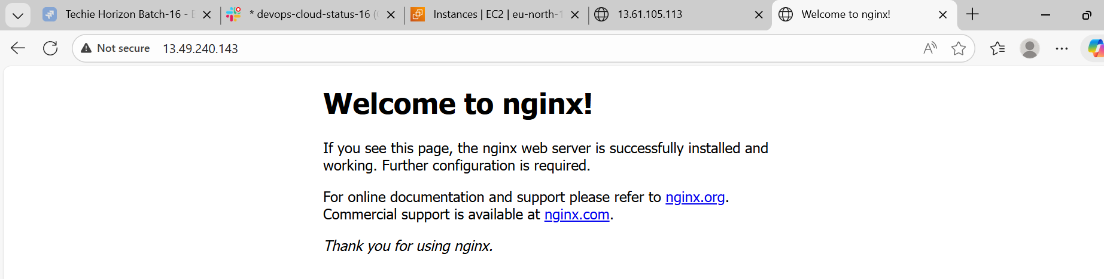

- Launch one Windows server and install Tomcat on Windows.

- Creating an instance named “Apache-windows”
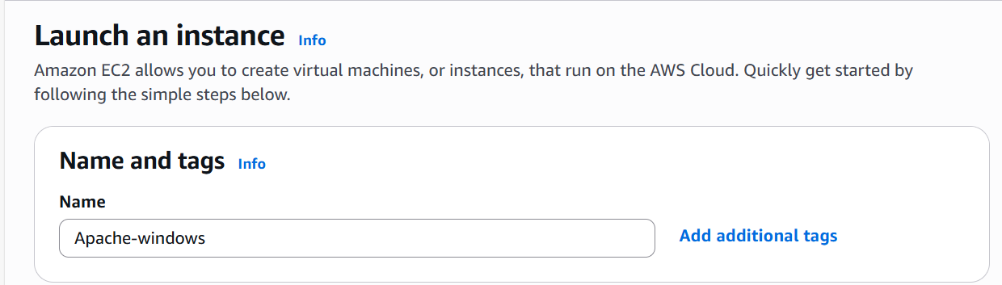

- Using AMI as Windows as per the requirement.
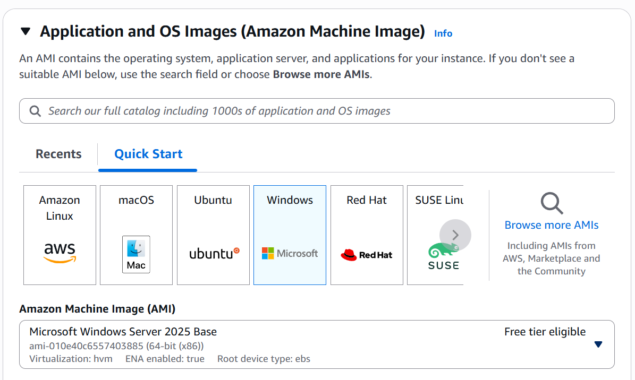

- Launch Instance
- Now Connect and open RDP client in the second tab and click “Set password”

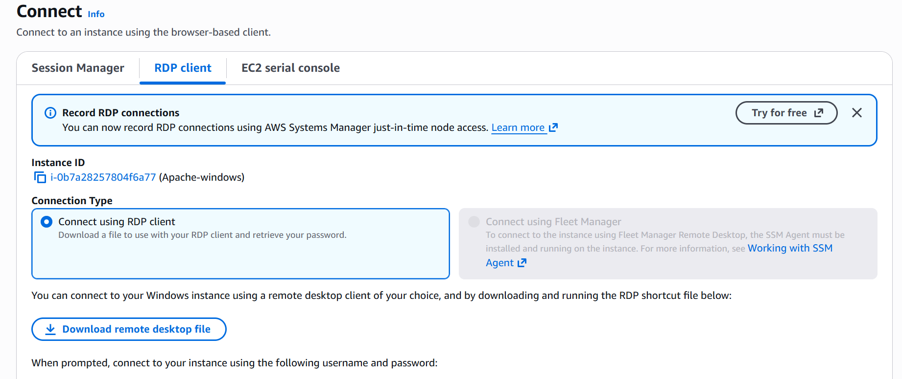
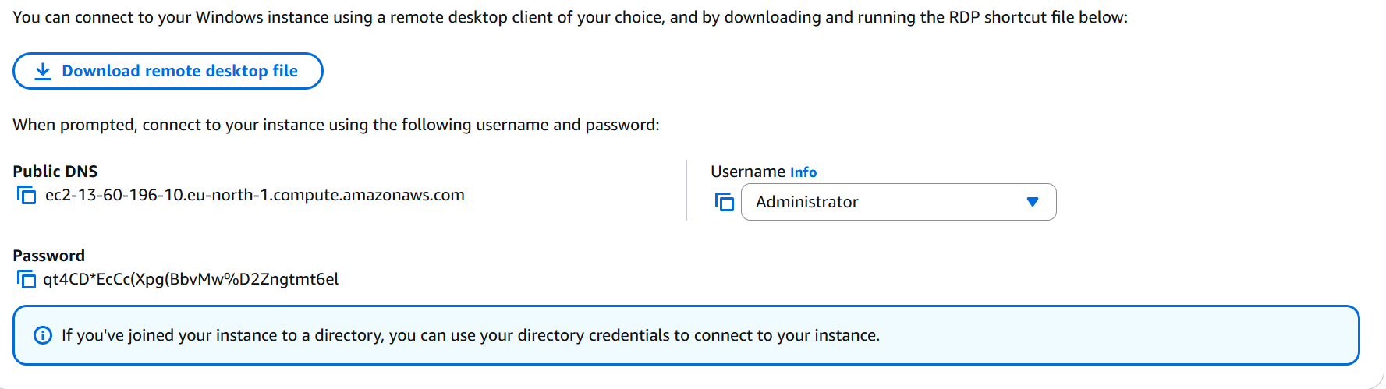
- Now add our pem.key from downloads and decrypt the file.

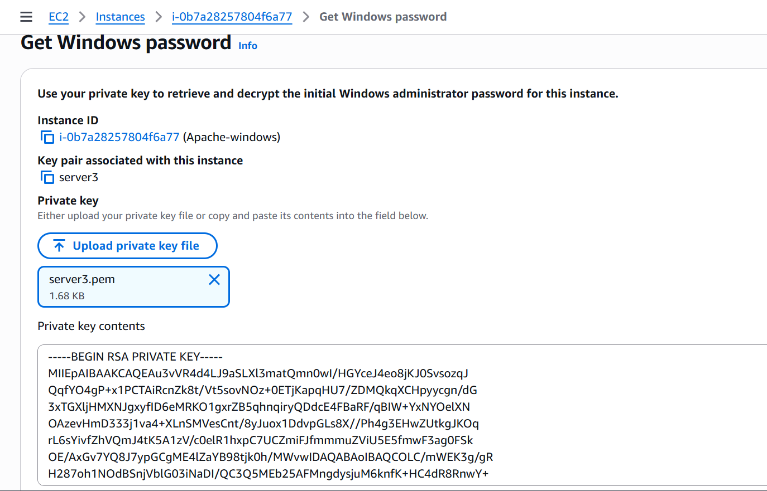

- Once password is copied and updated in “Private key contents”, then password will be generated.
- Now, “Download remote desktop file” and start the remote server.
- Go to the browser and download Java in website “Adoptium” and install Java.
- Install Apache Tomcat in browser via 32-64 bit Windows.
- Run Apache Tomcat and enter localhost:8080 in browser to verify if the Tomcat is installed.
- Success – the task is completed.

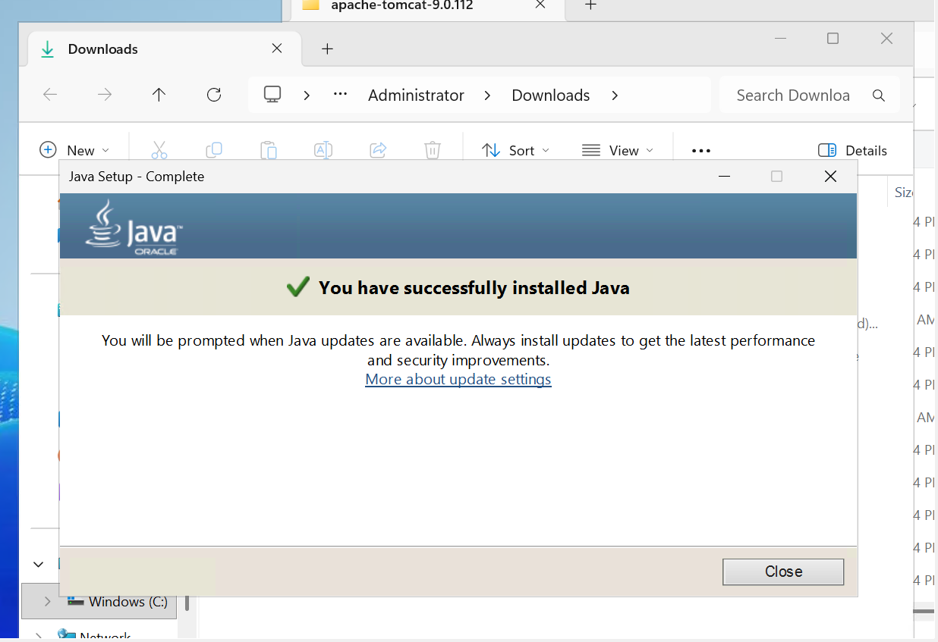

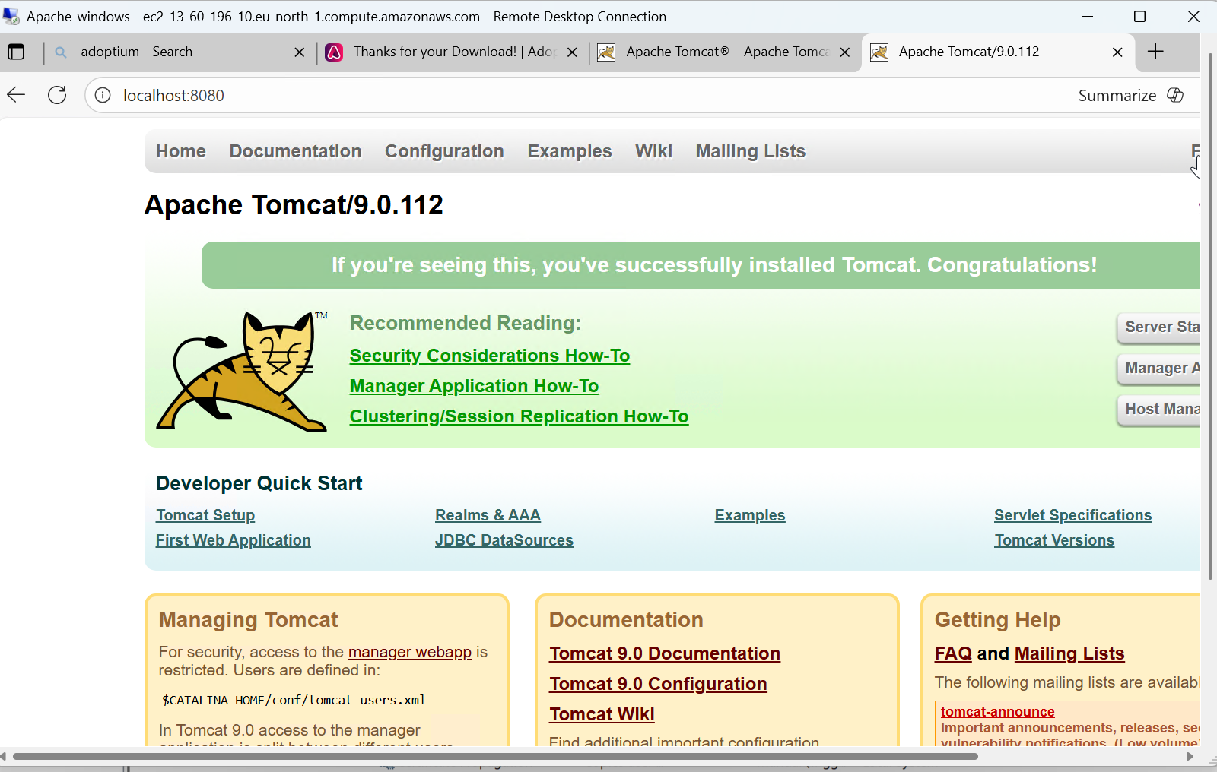

- Take a snapshot of the instance created in Task 1.
A Snapshot is a backup of an EBS Volume
(where your EC2 instance’s storage / disk lives).
Snapshot = Photo / Backup of your server’s disk
It contains:
• Operating system (Amazon Linux)
• Apache installation
• Your user-data installed files
• Any files you had on the server
So if your instance is deleted or corrupted, you can restore a new instance using the snapshot
- Scroll to the Volumes in EBS and select a instance.
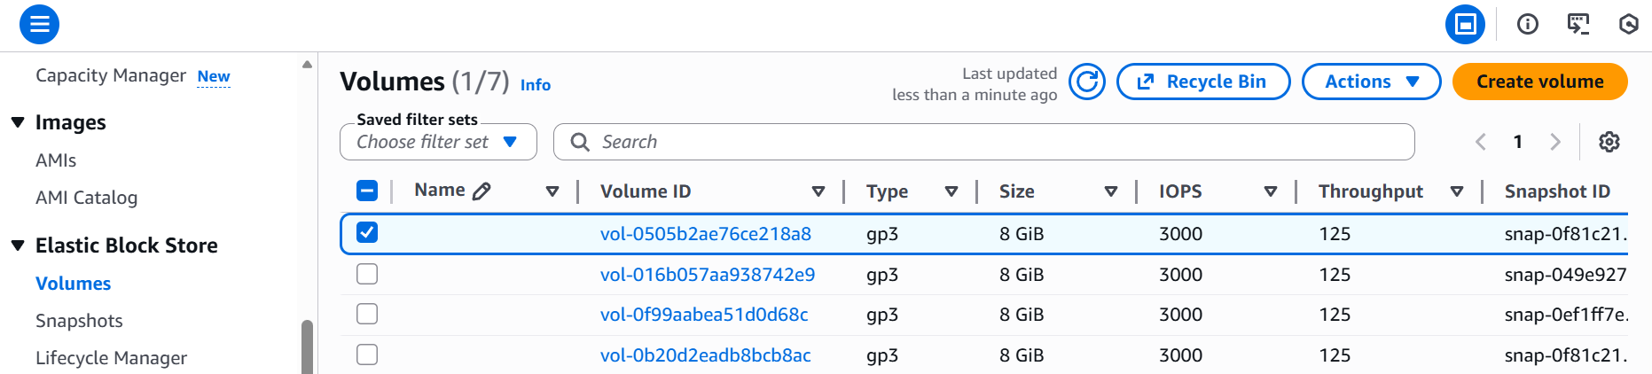

- Under actions- create snapshot.
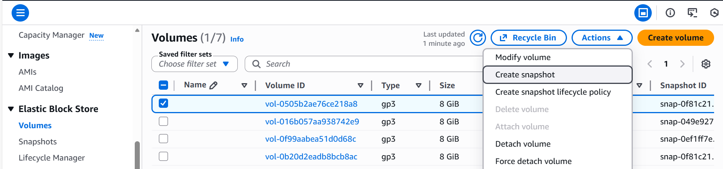

- Snapshot created by adding description for the better understanding.
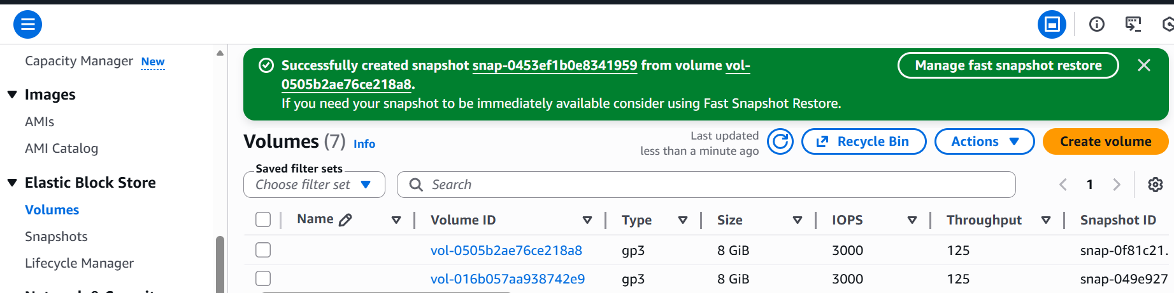

- Now, navigated to Snapshots in the EBS.
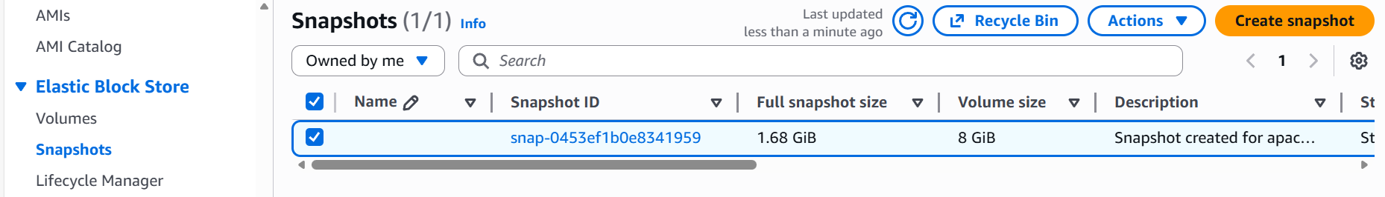

- Finally, we can verify the snapshot created and description found in Snapshot ID.
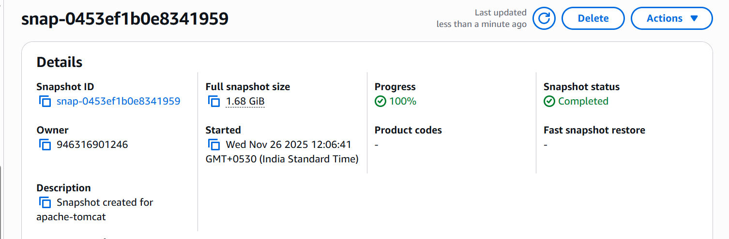

- Assign passwordless authentication for the EC2 created in Task 2.

- Start a Bash server in local machine and create a ssh-keygen with a command- ssh-keygen -t rsa
- Copy the ssh id and paste to the command to get the ssh key generated with including .pub
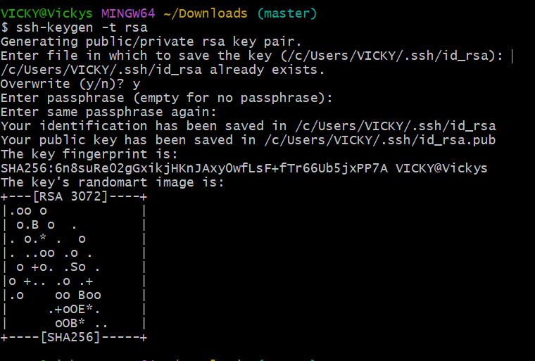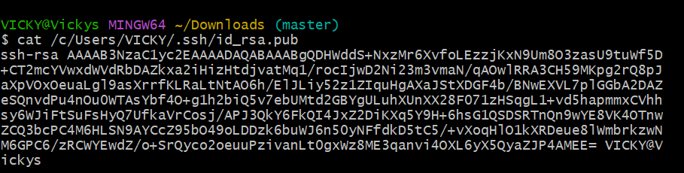

- In the Ubuntu server itself, create a directory to paste the ssh key as authorized key for the team member.
- Use command- Mkdir -p ~/.ssh to get the directory created for authorized key.
- Use command- vi ~/.ssh/authorized keys and paste the ssh-key in the file.
- Cat ~/.ssh/authorized_keys to read the ssh-key.

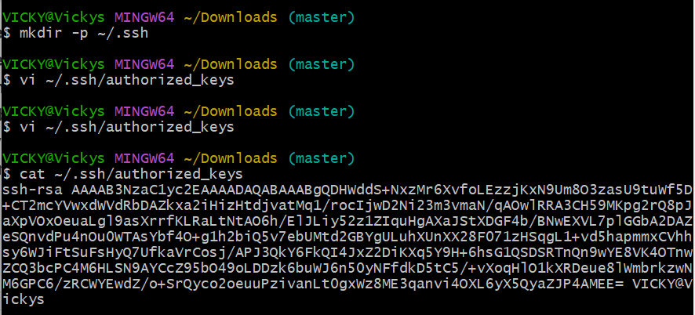

- From the ec2-server, select the ubuntu instance which we used for Task-2.
- Click on connect and copy the ssh.pem.key and paste in the local bash where we generated the ssh and directory created.
- Now the Ubuntu is successfully running in ec2-server with my local machine server.
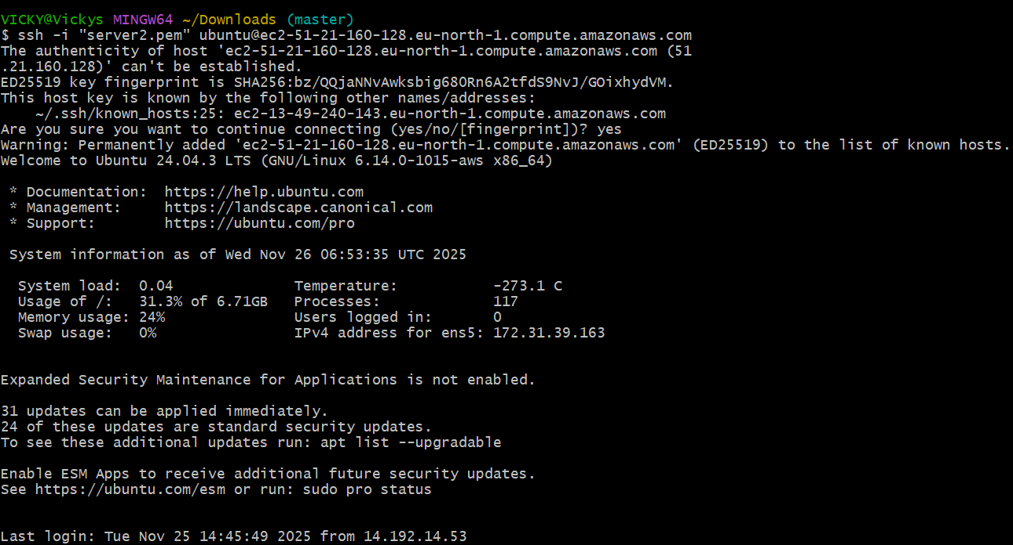

- The login succeeded without any password prompt, confirming that passwordless authentication was correctly set

- Passwordless SSH authentication was successfully enabled for the Ubuntu EC2 instance.
Now the user can log in securely using their SSH key without entering a password

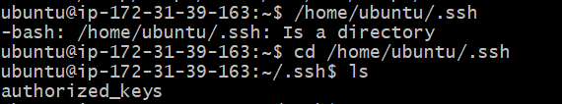

- Launch any EC2 using the spot purchasing option.

- Before launching a spot instance, we need to update our requirements in the left scroll bar.
- We updated the purchasing option and entered $1per hour.
- Valid set to “no expiry date”

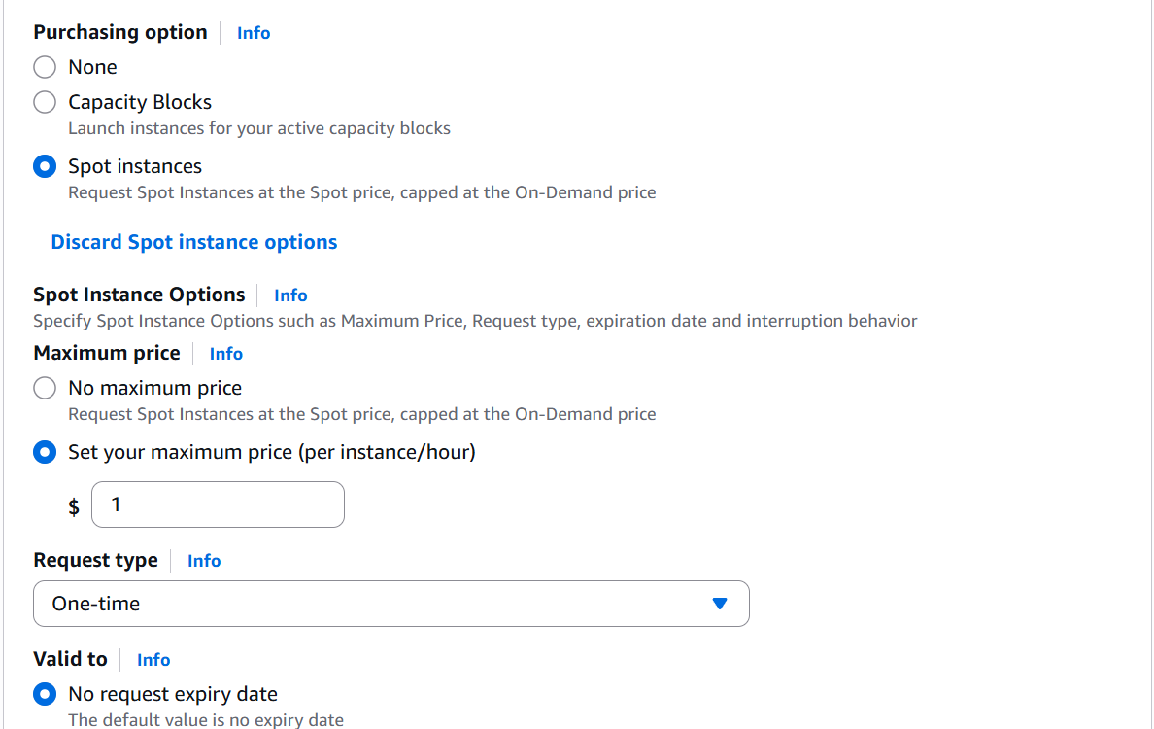

- Changed “Request type”, “Instance behaviour” and Tenancy as Dedicated as I do not want to lose my project.
- Success- Now we launched a instance with spot purchasing options.

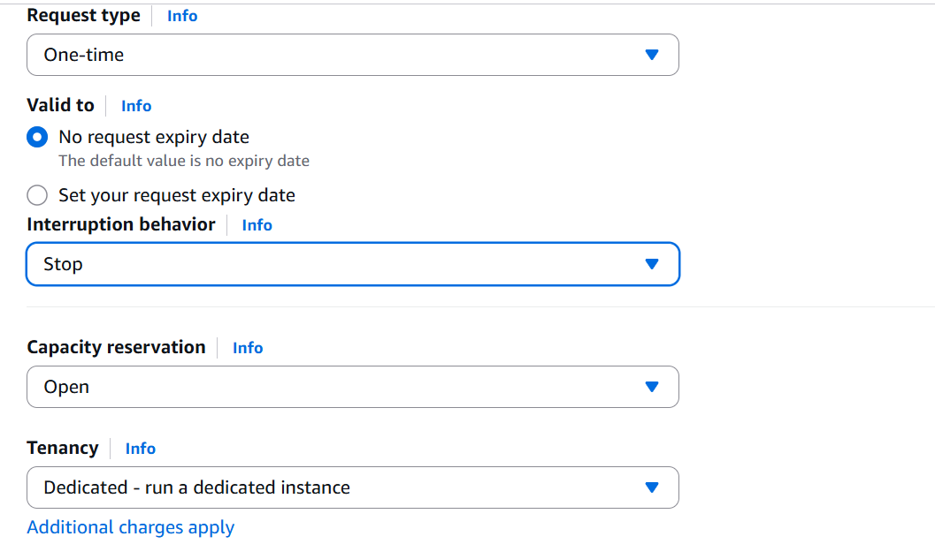

- Enable termination policy on the EC2 created in Task 2.

- Process is simple. Select the instance and go to Actions tab.
- In the Instance settings- select “Change termination protection”.

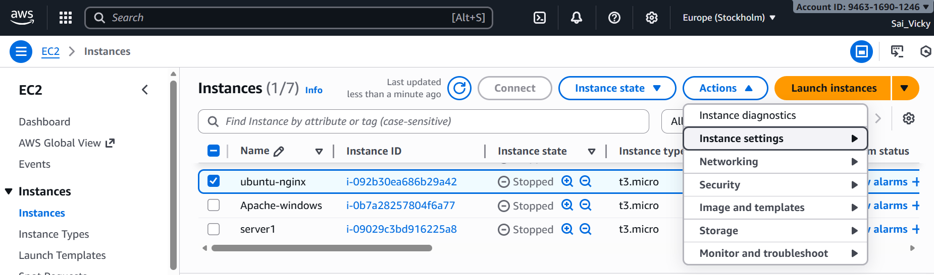

- Once the Change Termination protection is selected.
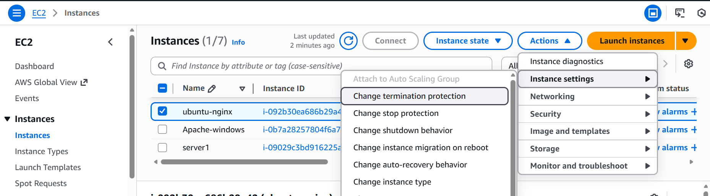

- It will ask you to Save.
- Now our ec-2 instance cannot be deleted. If anyone tries to delete, then they will get an error.
- Success- the task is completed.
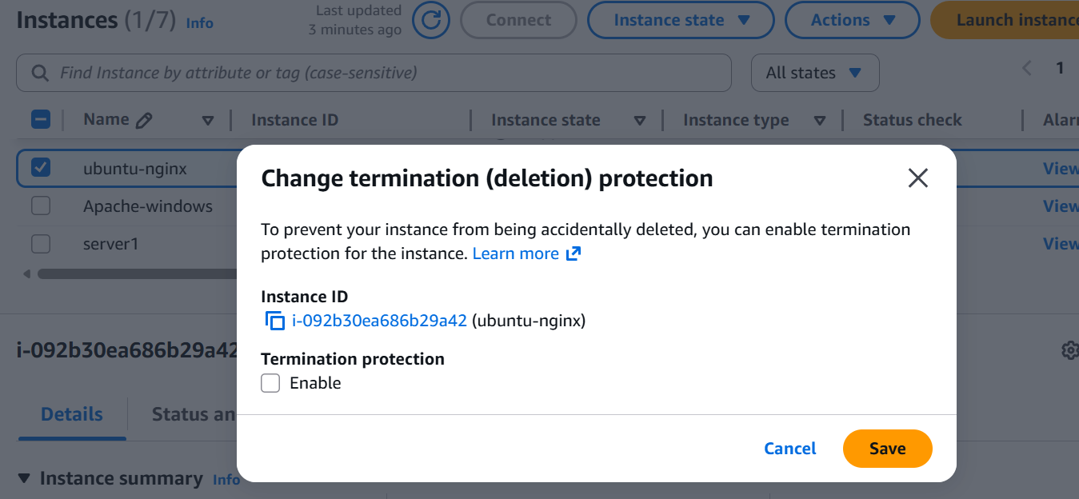

- Launch one EC2 using AWS CLI.
- Initial step is to create a User in AWS.
- Updated Security credentials and MFA in AWS.

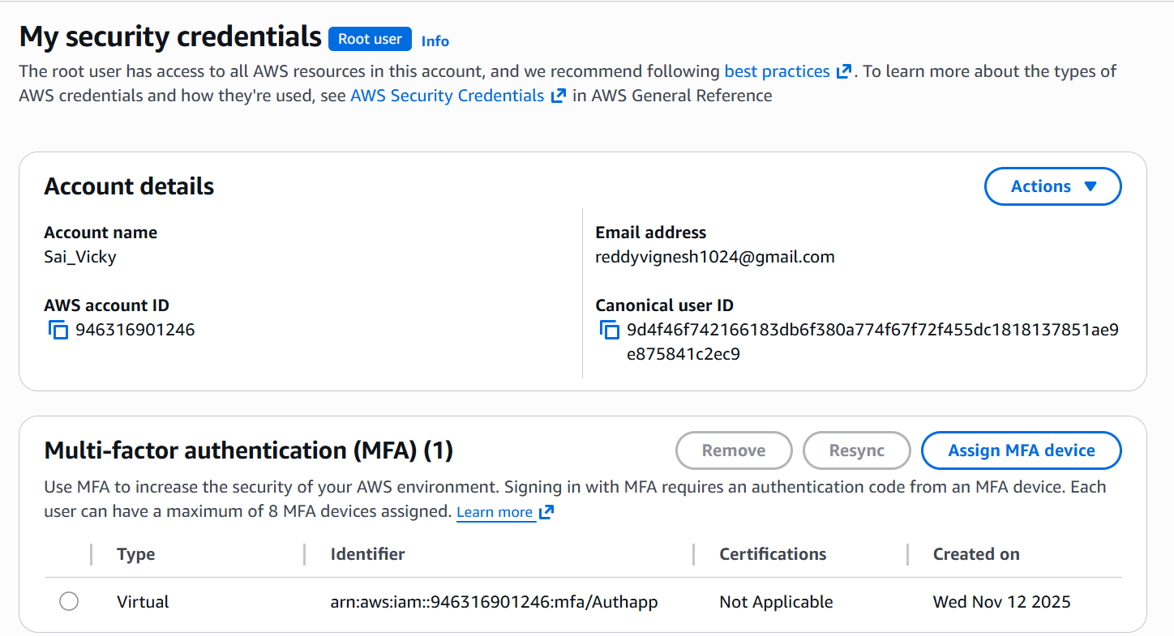

- Created Access Key in Access keys section.
- Access key created successfully.
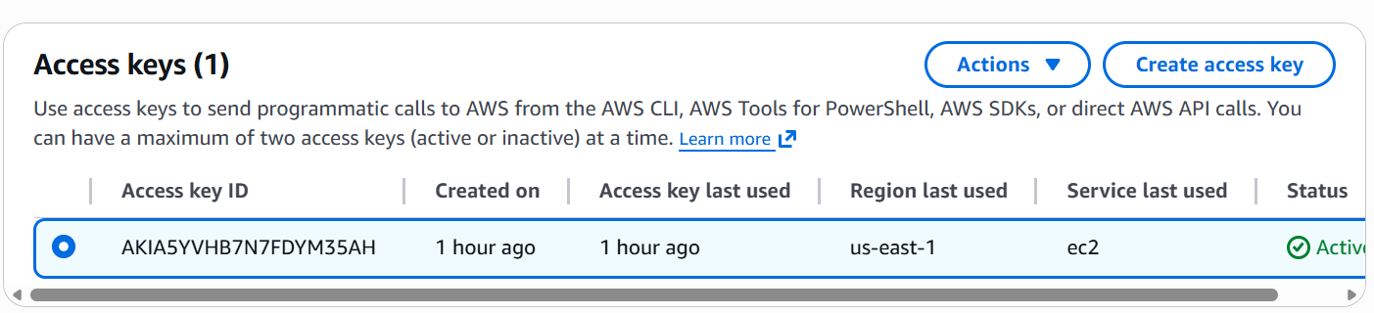

- Key pair created
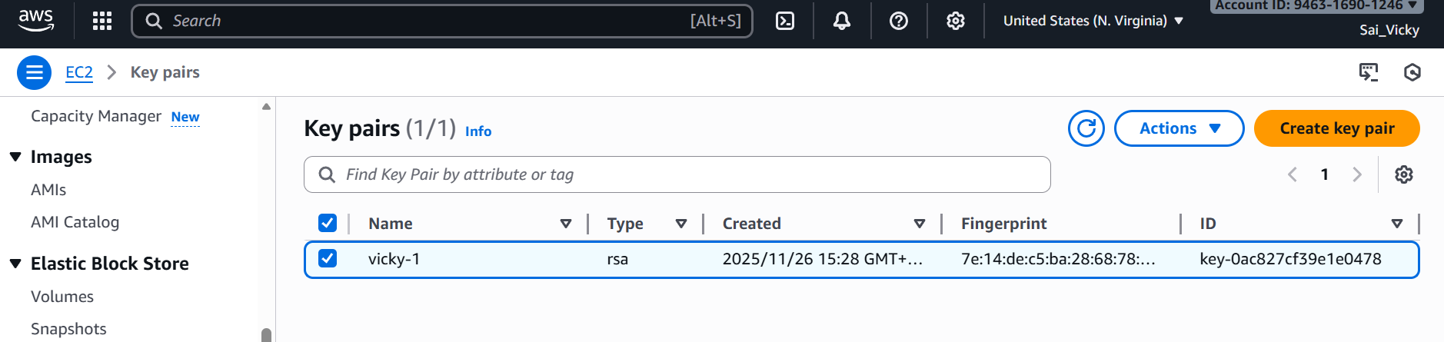
- Using command- aws configure we can configure aws instance with Access Key IDSecret Access Key from aws.
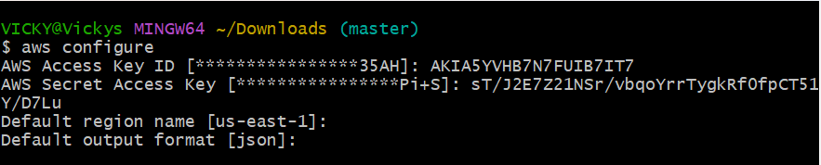
- I have created a security group in aws under Security groups. Using command- aws ec2 create-security-group –group name Vicky –description “My Cli Security Group”.
- To get the security group rules to local machine- aws ec2 authorize-security-group-ingress –groupname Vicky –protocol tcp –port 22 –cidr 0.0.0.0/0
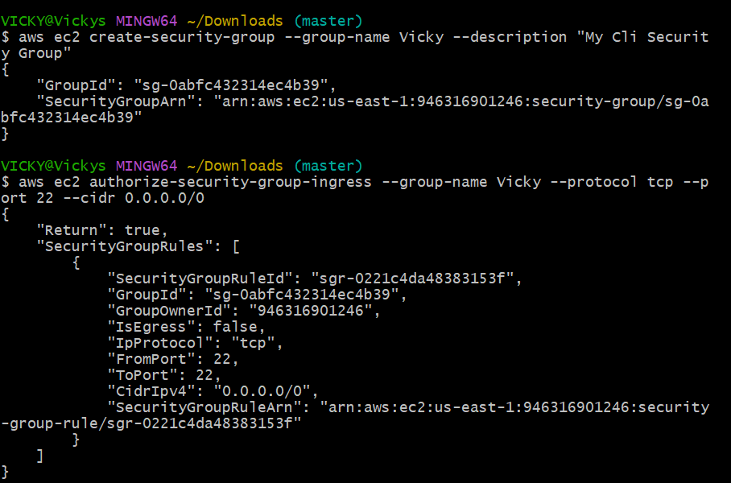

- I was getting error when running the instance in local machine git, but overcame the issue, where I was running the instance in Europe region, but my configure keys was in US-east1 region.
- Created a new instance in US-east1 and ran the instance in local machine.
- Success.
